DATABASE MANAGEMENT — SQL&PL/SQL

SECTION-A
SCENERIO-1

SCENARIO :
You are designing the database for a food delivery application. It stores restaurant details, menu items linked to each restaurant, and customer orders. You must decide which columns need NOT NULL constraints, which serve as PRIMARY KEYs, and which link tables via FOREIGN KEYs.
Question:
Justify your constraint choices for at least three columns across two tables. What data integrity problems would arise if these constraints were not applied?
ANS:
CREATE TABLE Restaurants (
restaurant_id INT PRIMARY KEY AUTO_INCREMENT,
restaurant_name VARCHAR(100) NOT NULL,
is_active TINYINT(1) DEFAULT 1
);

CREATE TABLE MenuItems (
item_id INT PRIMARY KEY AUTO_INCREMENT,
restaurant_id INT NOT NULL,
item_name VARCHAR(100) NOT NULL,
price DECIMAL(10, 2) NOT NULL,
FOREIGN KEY (restaurant_id) REFERENCES Restaurants(restaurant_id) ON DELETE CASCADE
);
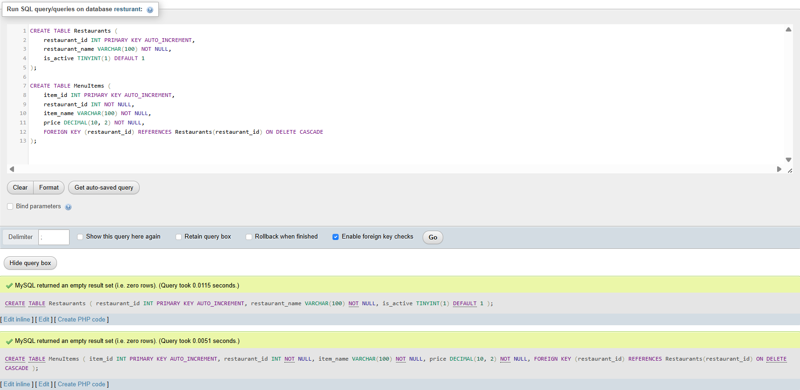
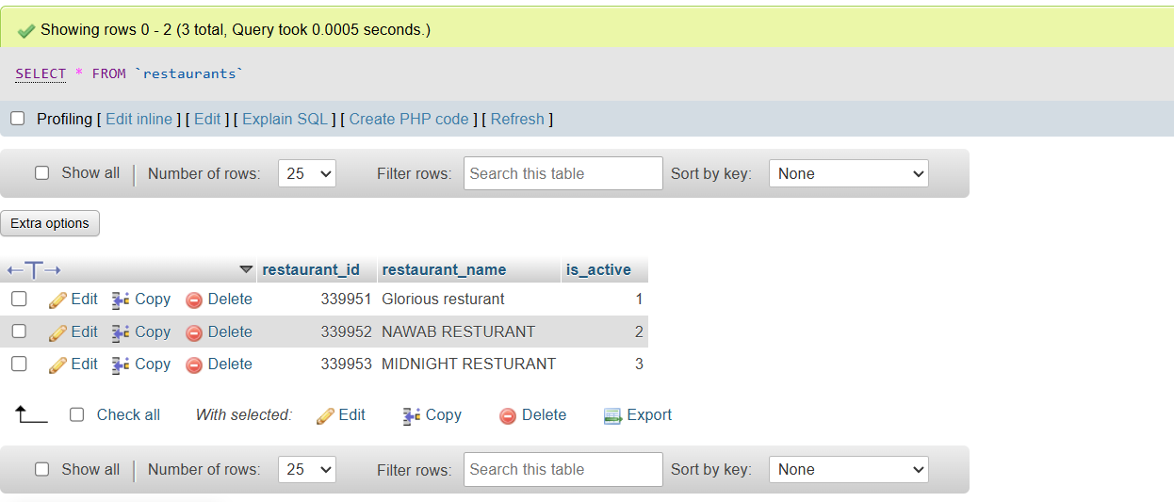
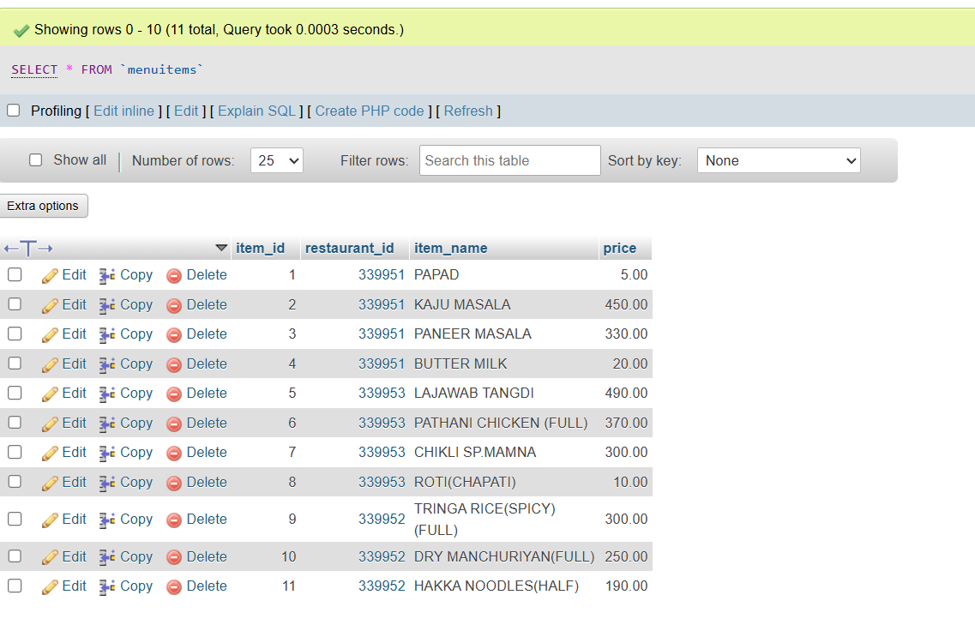
SCENERIO-2

SCENARIO :
You are managing the database for a food delivery platform. The operations team asks you to update the status of all orders placed more than 7 days ago that are still marked 'Pending' to 'Cancelled', and to permanently delete menu items marked 'Unavailable' from restaurants that have closed.
Question:
Explain why the WHERE clause is essential in each DML statement. What could go wrong with an UPDATE or DELETE executed without a proper WHERE condition?
ANS:
USE restaurant;
CREATE TABLE IF NOT EXISTS Orders (
order_id INT PRIMARY KEY AUTO_INCREMENT,
restaurant_id INT NOT NULL,
order_status VARCHAR(20) NOT NULL DEFAULT 'Pending',
total_amount DECIMAL(10, 2) NOT NULL DEFAULT 0.00,
order_date TIMESTAMP DEFAULT CURRENT_TIMESTAMP
);
UPDATE Orders
SET order_status = 'Cancelled'
WHERE order_status = 'Pending'
AND order_date < NOW() - INTERVAL 7 DAY;
DELETE FROM MenuItems
WHERE availability_status = 'Unavailable'
AND restaurant_id IN (
SELECT restaurant_id
FROM Restaurants
WHERE is_active = 0
);
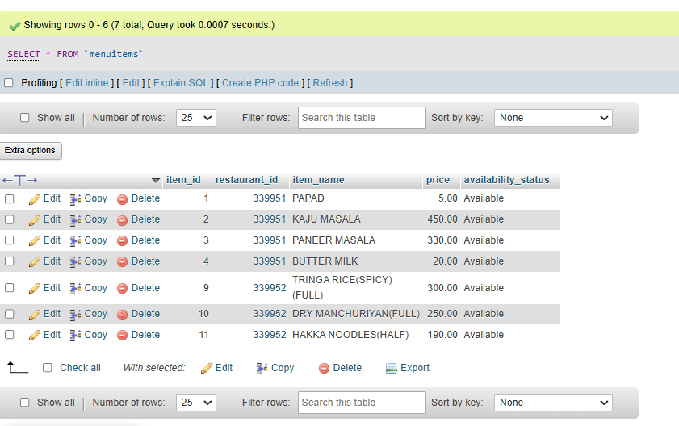

SCENERIO-3

SCENARIO:
You are building a revenue dashboard for a food delivery startup. The management wants total revenue, average order value, and number of orders per restaurant — but only for restaurants that have processed more than 20 orders in the current month.
Question:
Which SQL clauses and aggregate functions would you use to produce this report? Explain why HAVING must be used here rather than WHERE to filter by aggregate results.
ANS:
Key SQL Clauses & Aggregate Functions Used
To produce this revenue report, you use the following SQL aggregate functions and clauses:
1. Aggregate Functions
- COUNT(o.order_id): Calculates the total number of orders per restaurant.
- SUM(o.total_amount): Computes the total revenue by adding up the order amounts for each restaurant.
- AVG(o.total_amount): Calculates the Average Order Value (AOV) across all orders for that restaurant.
2. SQL Clauses
- WHERE: Filters raw, individual records before aggregation (limiting records strictly to orders placed in the current month).
- GROUP BY: Groups individual order records by restaurant_id and restaurant_name so aggregate calculations run per restaurant.
- HAVING: Filters the summary/grouped results after aggregation (restricting output to restaurants with more than 20 total orders).

SQL Query:
SELECT
r.restaurant_id,
r.restaurant_name,
COUNT(o.order_id) AS total_orders,
SUM(o.total_amount) AS total_revenue,
AVG(o.total_amount) AS average_order_value
FROM restaurants r
JOIN Orders o ON r.restaurant_id = o.restaurant_id
WHERE o.order_date >= DATE_FORMAT(NOW(), '%Y-%m-01')
GROUP BY r.restaurant_id, r.restaurant_name
HAVING COUNT(o.order_id) > 20;

Why HAVING Must Be Used Instead of WHERE :
- Order of Execution: In SQL execution order, the WHERE clause is processed before GROUP BY and aggregate computations occur. Because individual rows in the table do not store aggregate totals, evaluating WHERE COUNT(o.order_id) > 20 causes a syntax error.
- Post-Aggregation Filtering: The HAVING clause is specifically designed to run after the GROUP BY clause has collapsed individual rows into summary groups and calculated the aggregate metrics (COUNT, SUM, AVG). Therefore, filtering based on calculated conditions (like COUNT(o.order_id) > 20) requires HAVING.

SCENERIO-4
SCENARIO:
You are developing an order history page. The orders table has order_id, customer_id, restaurant_id, and total_amount. The restaurants table has restaurant_id and name. The page must show order ID, restaurant name, and amount for every order — including any that reference a restaurant no longer in the table.
Question:
Compare INNER JOIN and LEFT JOIN for this query. Which would you use and why? Describe what each join type does to records that have no match in the other table.
ANS:

Comparison of INNER JOIN vs. LEFT JOIN
Criteria | INNER JOIN | LEFT JOIN
Output Behavior | Returns only records where a matching key exists in both tables. | Returns all records from the left table (Orders), matching right table (Restaurants) records where available.
Unmatched Left Rows (Orders) | Discarded completely from query results. | Preserved in the output with NULL populated for right table columns.
Unmatched Right Rows (Restaurants) | Discarded completely from query results. | Discarded from query results.

SQL QUERY:
SELECT
o.order_id,
COALESCE(r.name, 'Unknown Restaurant') AS restaurant_name,
o.total_amount
FROM Orders o
LEFT JOIN Restaurants r ON o.restaurant_id = r.restaurant_id;

Why LEFT JOIN is the Required Choice
- Handling Deleted Restaurants: The scenario explicitly mandates displaying every order—including those referencing a restaurant no longer in the Restaurants table.
- Behavior of INNER JOIN: If you used an INNER JOIN, any order associated with a deleted restaurant_id would fail to match and be silently excluded from the output. This would corrupt customer order histories and distort order volume totals.
- Behavior of LEFT JOIN: A LEFT JOIN keeps every order record intact. If a restaurant has been removed, the query populates r.name as NULL (which can be cleanly wrapped with COALESCE to display a fallback string like 'Unknown Restaurant').

SCENERIO-5
SCENARIO:
You are building the analytics layer for a food delivery platform. A senior developer proposes a VIEW called top_restaurants showing restaurant name, total orders, and average rating — hiding raw ID columns from the front-end team.
Question:
Justify why a VIEW is preferred over direct table access here. What are two limitations the front-end developer should be aware of when working with this VIEW?
ANS:
Justification: Why a VIEW is Preferred
- Security & Column-Level Access Control: A view hides sensitive or internal schema details (such as raw database keys, foreign keys, or internal flags) while restricting the front-end team to read-only access on approved business metrics.
- Simplified Complexity: The front-end team does not need to repeatedly write or maintain complex JOIN, GROUP BY, or AVG logic. They can query the view as if it were a flat single table (SELECT * FROM top_restaurants;).
- Decoupled Architecture: If the underlying database schema changes (e.g., table renaming, schema normalization, or column structural updates), database administrators can adjust the view definition without breaking front-end code.

Two Limitations for Front-End Developers
- Read-Only / Non-Updatable Operations: Because top_restaurants involves aggregate functions (COUNT, AVG) and a GROUP BY clause, MySQL marks it as non-updatable. The front-end developer cannot execute UPDATE, INSERT, or DELETE statements on this view.
- Performance Constraints on Large Datasets: Non-materialized MySQL views evaluate dynamically every time they are queried. If the front-end team executes heavy filtering or sorting operations on top_restaurants over millions of order rows, query execution can cause performance bottlenecks since underlying indexes on raw tables may not optimize through the view abstraction layer.
SCENERIO-6

SCENARIO:

You are implementing the payment module for a food delivery app. When a customer places an order, the system must deduct the amount from the customer's wallet balance and record the payment simultaneously. During load testing, the wallet deduction completes but the payment record insert occasionally fails, leaving balances inconsistent.

Question:

Which database mechanism should have prevented this inconsistency? Explain how COMMIT, ROLLBACK, and SAVEPOINT work together to ensure both operations succeed or neither takes effect.
ANS:
The database mechanism that should have prevented this inconsistency is Database Transactions (ACID Compliance) using explicit transaction controls.
Specifically, this scenario violates the Atomicity property, which mandates that a series of operations must either completely succeed together or completely fail together.

How COMMIT, ROLLBACK, and SAVEPOINT Work Together
- COMMIT: Makes all uncommitted changes permanent in the database. If both the UPDATE and INSERT execute without errors, COMMIT writes both changes to disk simultaneously. Until COMMIT is executed, no other database connection sees the deducted balance as final.
- ROLLBACK: Reverts the entire transaction state back to how it was before START TRANSACTION was called. If the payment record INSERT fails due to a network glitch, primary key conflict, or system timeout, calling ROLLBACK undoes the wallet deduction instantly, ensuring the customer's balance remains untouched.
- SAVEPOINT: Creates an intermediate checkpoint within a large or complex transaction (e.g., SAVEPOINT pre_insert;). If a secondary action fails, you can use ROLLBACK TO SAVEPOINT pre_insert to undo only that specific step or log an alternative retry attempt without losing the initial, validated parts of your execution context before deciding whether to perform a full ROLLBACK or final COMMIT.

SECTION-B
TASK-1
Design and Populate a Restaurant Database:
Create a structured schema for a food delivery system and populate it with sample data using DDL and DML commands.
- reate a database named foodapp_db and a table named restaurants with columns: restaurant_id (INT, AUTO_INCREMENT, PRIMARY KEY), name (VARCHAR, NOT NULL), city (VARCHAR), cuisine_type (VARCHAR), and rating (DECIMAL(3,1)).
- Insert at least 6 restaurant records spanning at least 3 different cities.
- Update the rating of one restaurant and delete one restaurant record using a WHERE condition.
- Write a SELECT query that retrieves all restaurants sorted by rating in descending order.
ANS:
CREATE DATABASE IF NOT EXISTS foodapp_db;
USE foodapp_db;

CREATE TABLE IF NOT EXISTS restaurants (
restaurant_id INT AUTO_INCREMENT PRIMARY KEY,
name VARCHAR(100) NOT NULL,
city VARCHAR(50),
cuisine_type VARCHAR(50),
rating DECIMAL(3,1)
);

INSERT INTO restaurants (name, city, cuisine_type, rating)
VALUES
('Surat Sizzlers', 'Surat', 'North Indian', 4.5),
('Bombay Bites', 'Mumbai', 'Street Food', 4.2),
('Delhi Darbar', 'Delhi', 'Mughlai', 4.8),
('Tapi Treats', 'Surat', 'Gujarati', 4.1),
('Marine Drive Meals', 'Mumbai', 'Seafood', 4.6),
('Capital Curries', 'Delhi', 'Punjabi', 3.9);

UPDATE restaurants
SET rating = 4.7
WHERE name = 'Surat Sizzlers';

DELETE FROM restaurants
WHERE name = 'Capital Curries';

SELECT *
FROM restaurants
ORDER BY rating DESC;
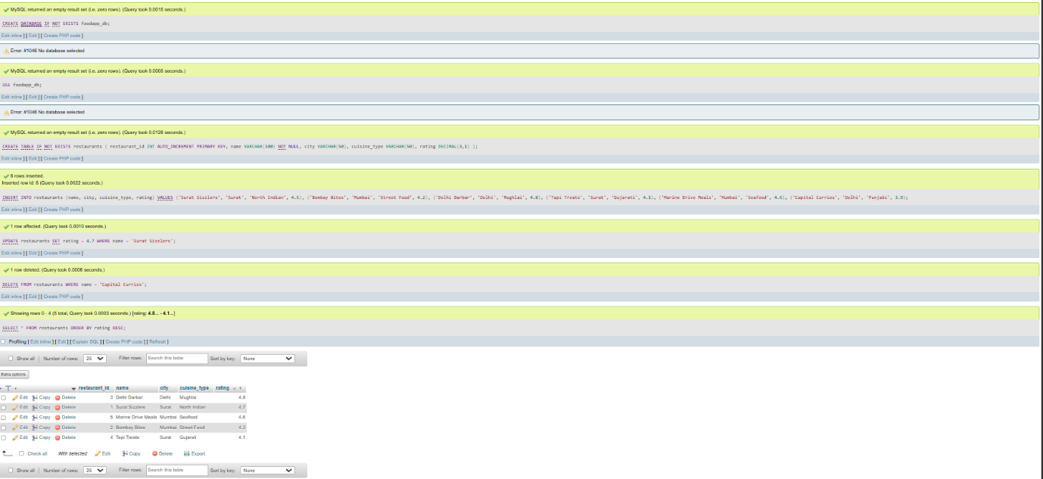
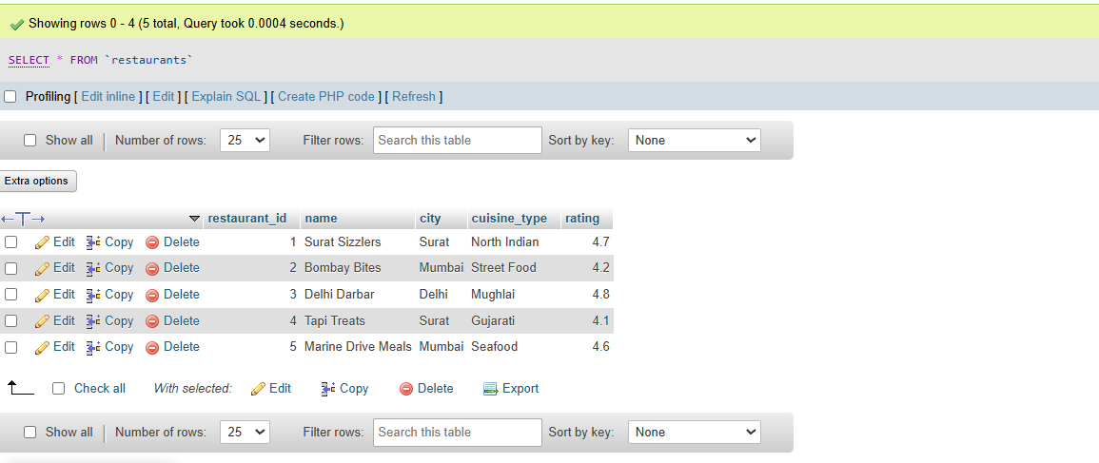

Task 2:
Aggregate Revenue Reporting on Orders
Write SELECT queries using aggregate functions and GROUP BY to produce a restaurant-level revenue summary from order data.
  - Create an orders table with columns: order_id, restaurant_id, customer_name, total_amount, and order_date. Insert at least 12 orders distributed across at least 4 restaurants.
  - Write a query to show total revenue and average order value per restaurant.
  - Write a query using HAVING to list only restaurants whose total revenue exceeds Rs 5,000.
  - Write a query to retrieve the 5 most recent orders using ORDER BY and LIMIT.
ANS:
USE foodapp_db;

CREATE TABLE IF NOT EXISTS orders (
order_id INT AUTO_INCREMENT PRIMARY KEY,
restaurant_id INT NOT NULL,
customer_name VARCHAR(100) NOT NULL,
total_amount DECIMAL(10, 2) NOT NULL,
order_date TIMESTAMP DEFAULT CURRENT_TIMESTAMP,
FOREIGN KEY (restaurant_id) REFERENCES restaurants(restaurant_id) ON DELETE CASCADE
);

INSERT INTO orders (restaurant_id, customer_name, total_amount, order_date)
VALUES
(1, 'Aarav Sharma', 2400.00, '2026-09-01 12:30:00'),
(1, 'Priya Patel', 3100.00, '2026-09-02 13:15:00'),
(1, 'Rohan Gupta', 1800.00, '2026-09-03 20:00:00'),
(2, 'Neha Verma', 1200.00, '2026-09-01 19:45:00'),
(2, 'Karan Singh', 950.00, '2026-09-02 14:10:00'),
(2, 'Ananya Roy', 800.00, '2026-09-04 21:00:00'),
(3, 'Vikram Malhotra', 4500.00, '2026-09-01 20:30:00'),
(3, 'Sanya Malhotra', 3800.00, '2026-09-03 13:00:00'),
(3, 'Dev Patel', 2900.00, '2026-09-05 15:30:00'),
(4, 'Meera Joshi', 1500.00, '2026-09-02 18:20:00'),
(4, 'Rahul Mehta', 2100.00, '2026-09-04 19:10:00'),
(4, 'Pooja Shah', 1800.00, '2026-09-05 16:00:00');

SELECT
r.restaurant_id,
r.name AS restaurant_name,
COUNT(o.order_id) AS total_orders,
SUM(o.total_amount) AS total_revenue,
ROUND(AVG(o.total_amount), 2) AS average_order_value
FROM restaurants r
JOIN orders o ON r.restaurant_id = o.restaurant_id
GROUP BY r.restaurant_id, r.name;

SELECT
r.restaurant_id,
r.name AS restaurant_name,
SUM(o.total_amount) AS total_revenue
FROM restaurants r
JOIN orders o ON r.restaurant_id = o.restaurant_id
GROUP BY r.restaurant_id, r.name
HAVING SUM(o.total_amount) > 5000.00;

SELECT
order_id,
customer_name,
total_amount,
order_date
FROM orders
ORDER BY order_date DESC
LIMIT 5;

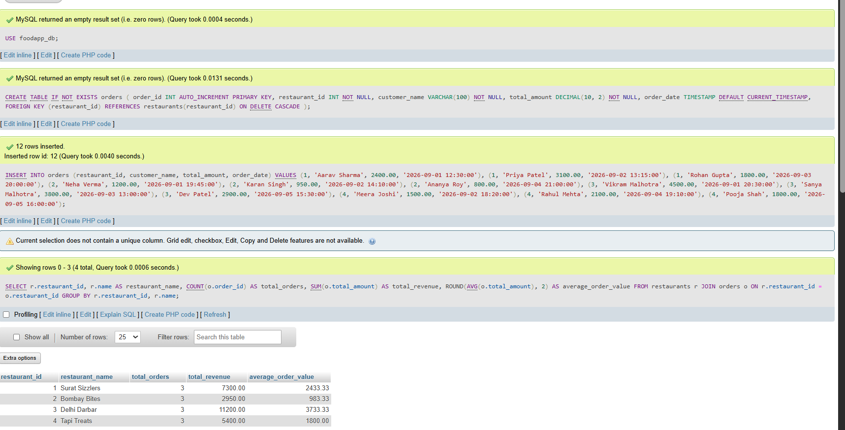
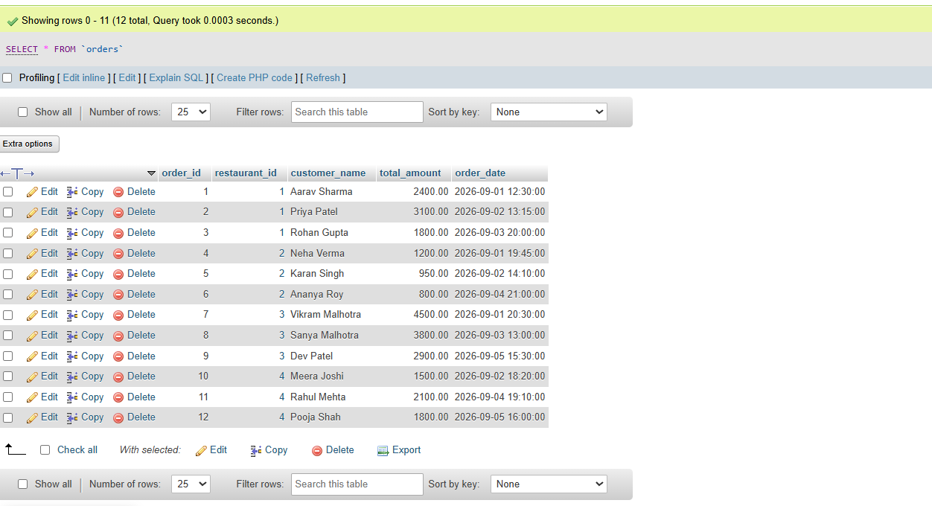
Task 3:
Multi-Table JOINs and Menu Summary View
Build a two-table schema for restaurants and menu items, write JOIN queries to combine data, and create a summary VIEW.
- Create two tables: restaurants (restaurant_id, name, city) and menu_items (item_id, restaurant_id, item_name, price, category). Link them with a FOREIGN KEY on restaurant_id.
- Insert at least 5 restaurants and 12 menu items; at least one restaurant must have no menu items.
- Write an INNER JOIN query listing restaurant name, item name, and price for all available items.
- Write a LEFT JOIN query so that restaurants with no items also appear in results, with NULL values in item columns.
- Create a VIEW named restaurant_menu_summary showing restaurant name, total number of menu items, and average item price grouped by restaurant.
ANS:
USE foodapp_db;

CREATE TABLE IF NOT EXISTS menu_items (
item_id INT AUTO_INCREMENT PRIMARY KEY,
restaurant_id INT NOT NULL,
item_name VARCHAR(100) NOT NULL,
price DECIMAL(10, 2) NOT NULL,
category VARCHAR(50),
FOREIGN KEY (restaurant_id) REFERENCES restaurants(restaurant_id) ON DELETE CASCADE
);

INSERT INTO restaurants (name, city, cuisine_type, rating) VALUES
('The Grand Thali', 'Surat', 'Gujarati', 4.5),
('Spice Villa', 'Surat', 'Multi-Cuisine', 4.3),
('Punjab Express', 'Delhi', 'North Indian', 4.0),
('Salsa Grill', 'Mumbai', 'Mexican', 4.2),
('Royal Cafe', 'Mumbai', 'Cafe', 3.8); -- Restaurant with 0 menu items

INSERT INTO menu_items (restaurant_id, item_name, price, category) VALUES
(1, 'Gujarati Thali', 350.00, 'Main Course'),
(1, 'Khaman Dhokla', 120.00, 'Snacks'),
(1, 'Masala Chhas', 40.00, 'Beverage'),
(2, 'Paneer Tikka', 280.00, 'Starter'),
(2, 'Veg Biryani', 320.00, 'Main Course'),
(2, 'Sizzling Brownie', 220.00, 'Dessert'),
(3, 'Butter Chicken', 380.00, 'Main Course'),
(3, 'Garlic Naan', 60.00, 'Bread'),
(3, 'Lassi', 90.00, 'Beverage'),
(4, 'Veg Tacos', 250.00, 'Starter'),
(4, 'Burrito Bowl', 340.00, 'Main Course'),
(4, 'Churros', 180.00, 'Dessert');

SELECT
r.name AS restaurant_name,
m.item_name,
m.price
FROM restaurants r
INNER JOIN menu_items m ON r.restaurant_id = m.restaurant_id;

SELECT
r.name AS restaurant_name,
m.item_name,
m.price
FROM restaurants r
LEFT JOIN menu_items m ON r.restaurant_id = m.restaurant_id;

CREATE OR REPLACE VIEW restaurant_menu_summary AS
SELECT
r.name AS restaurant_name,
COUNT(m.item_id) AS total_menu_items,
ROUND(IFNULL(AVG(m.price), 0), 2) AS average_item_price
FROM restaurants r
LEFT JOIN menu_items m ON r.restaurant_id = m.restaurant_id
GROUP BY r.restaurant_id, r.name;
SELECT * FROM restaurant_menu_summary;
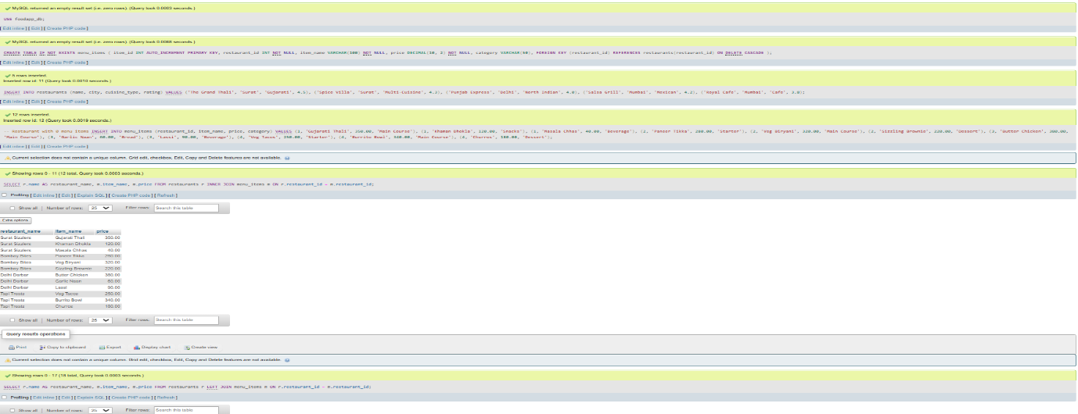
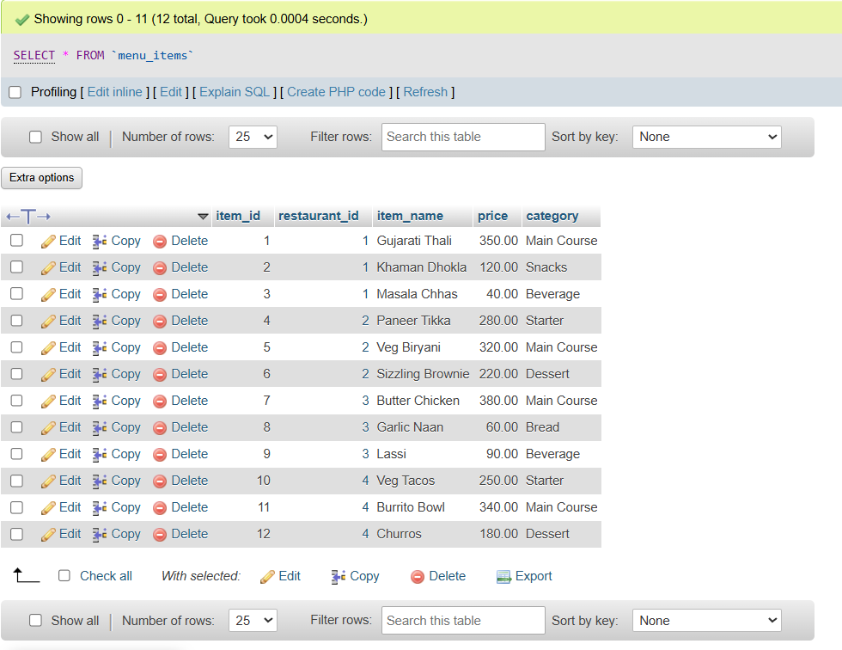
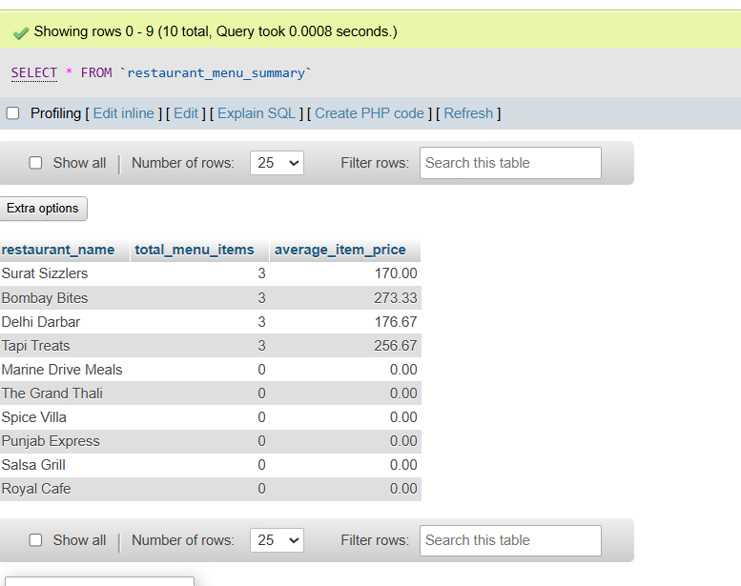

Task 4:
PL/SQL Order Placement Procedure
Write a stored procedure to process a customer order with wallet deduction and full transaction control.
- Create a stored procedure named place_order that accepts customer_id, restaurant_id, and amount as parameters.
- Deduct the amount from the customer’s wallet_balance in a customers table and insert a new record into the orders table.
- Use a transaction block: if the customer's wallet_balance is insufficient, ROLLBACK everything; otherwise COMMIT.
- Test with a valid order and an order exceeding wallet balance. Screenshot both outcomes from MySQL Workbench.
ANS:
USE foodapp_db;

CREATE TABLE IF NOT EXISTS customers (
customer_id INT AUTO_INCREMENT PRIMARY KEY,
name VARCHAR(100) NOT NULL,
wallet_balance DECIMAL(10, 2) NOT NULL DEFAULT 0.00
);

INSERT INTO customers (customer_id, name, wallet_balance)
VALUES (1, 'Rahul Sharma', 1000.00)
ON DUPLICATE KEY UPDATE wallet_balance = 1000.00;

DELIMITER //

CREATE PROCEDURE place_order(
IN p_customer_id INT,
IN p_restaurant_id INT,
IN p_amount DECIMAL(10, 2)
)
BEGIN
DECLARE current_balance DECIMAL(10, 2);

DECLARE EXIT HANDLER FOR SQLEXCEPTION
BEGIN
ROLLBACK;
SELECT 'Transaction Failed: System or Database Error' AS status_message;
END;

START TRANSACTION;

SELECT wallet_balance INTO current_balance
FROM customers
WHERE customer_id = p_customer_id;

IF current_balance IS NULL THEN
ROLLBACK;
SELECT 'Transaction Failed: Customer ID Not Found' AS status_message;
ELSEIF current_balance < p_amount THEN
ROLLBACK;
SELECT CONCAT('Transaction Failed: Insufficient Wallet Balance. Current: Rs ', current_balance, ', Required: Rs ', p_amount) AS status_message;
ELSE
UPDATE customers
SET wallet_balance = wallet_balance - p_amount
WHERE customer_id = p_customer_id;

INSERT INTO orders (restaurant_id, customer_name, total_amount, order_date)
SELECT p_restaurant_id, name, p_amount, NOW()
FROM customers
WHERE customer_id = p_customer_id;

COMMIT;
SELECT CONCAT('Order Placed Successfully! Remaining Balance: Rs ', (current_balance - p_amount)) AS status_message;
END IF;
END //

DELIMITER ;

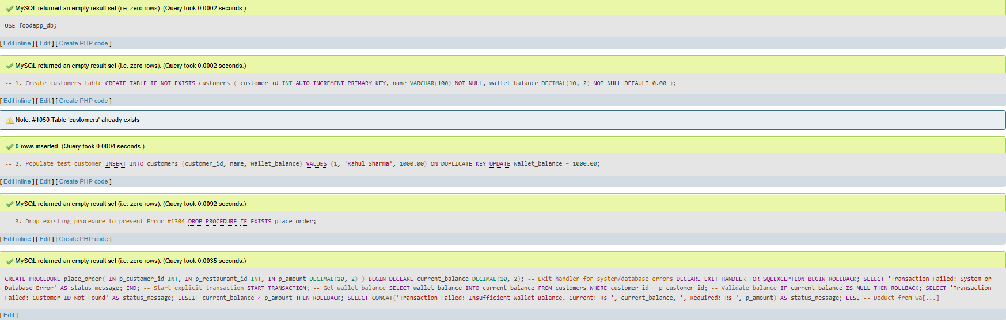
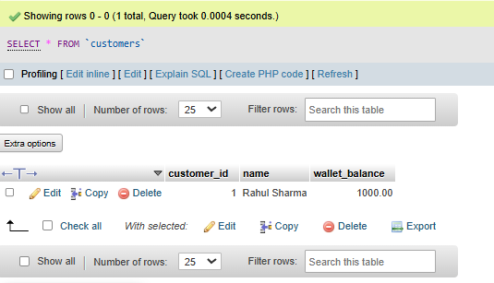

SECTION-C
Mini Project:
Food Delivery Platform — Backend Database
Objective:
Build the complete backend database for a Food Delivery application, combining DDL, DML, JOINs, Views, and PL/SQL into a single integrated .sql script.
Your project must:
- Create three tables: restaurants (restaurant_id, name, city, cuisine_type, created_at), menu_items (item_id, restaurant_id, item_name, price, category) with a FOREIGN KEY on restaurant_id, and orders (order_id, customer_name, restaurant_id, item_id, quantity, total_amount, order_date) with a FOREIGN KEY on restaurant_id — all with appropriate PRIMARY KEY and NOT NULL constraints.
- Populate with at least 3 restaurants, 4 menu categories, and 15 order records distributed across restaurants.
- Create a VIEW named restaurant_sales_summary showing restaurant name, total number of orders, and total revenue grouped by restaurant.
- Write a stored procedure named add_order that accepts customer_name, restaurant_id, item_id, and quantity, calculates total_amount from the menu item price, validates the restaurant exists (ROLLBACK if not), and inserts the order record.
- Write a TRIGGER named after_order_insert that logs a record into an order_audit table (order_id, restaurant_id, action='INSERT', log_time=NOW()) immediately after every new order is created.

ANS:
CREATE DATABASE IF NOT EXISTS food_delivery_db;
USE food_delivery_db;

DROP VIEW IF EXISTS restaurant_sales_summary;
DROP TRIGGER IF EXISTS after_order_insert;
DROP PROCEDURE IF EXISTS add_order;
DROP TABLE IF EXISTS order_audit;
DROP TABLE IF EXISTS orders;
DROP TABLE IF EXISTS menu_items;
DROP TABLE IF EXISTS restaurants;

-- Table 1: Restaurants
CREATE TABLE restaurants (
restaurant_id INT AUTO_INCREMENT PRIMARY KEY,
name VARCHAR(100) NOT NULL,
city VARCHAR(50) NOT NULL,
cuisine_type VARCHAR(50) NOT NULL,
created_at TIMESTAMP DEFAULT CURRENT_TIMESTAMP
);

-- Table 2: Menu Items
CREATE TABLE menu_items (
item_id INT AUTO_INCREMENT PRIMARY KEY,
restaurant_id INT NOT NULL,
item_name VARCHAR(100) NOT NULL,
price DECIMAL(10, 2) NOT NULL,
category VARCHAR(50) NOT NULL,
FOREIGN KEY (restaurant_id) REFERENCES restaurants(restaurant_id) ON DELETE CASCADE
);

-- Table 3: Orders
CREATE TABLE orders (
order_id INT AUTO_INCREMENT PRIMARY KEY,
customer_name VARCHAR(100) NOT NULL,
restaurant_id INT NOT NULL,
item_id INT NOT NULL,
quantity INT NOT NULL,
total_amount DECIMAL(10, 2) NOT NULL,
order_date TIMESTAMP DEFAULT CURRENT_TIMESTAMP,
FOREIGN KEY (restaurant_id) REFERENCES restaurants(restaurant_id) ON DELETE CASCADE,
FOREIGN KEY (item_id) REFERENCES menu_items(item_id) ON DELETE CASCADE
);

-- Table 4: Order Audit Log (Required for Trigger)
CREATE TABLE order_audit (
audit_id INT AUTO_INCREMENT PRIMARY KEY,
order_id INT NOT NULL,
restaurant_id INT NOT NULL,
action VARCHAR(20) NOT NULL DEFAULT 'INSERT',
log_time TIMESTAMP DEFAULT CURRENT_TIMESTAMP
);

-- Populate 3 Restaurants
INSERT INTO restaurants (restaurant_id, name, city, cuisine_type) VALUES
(1, 'Glorious Restaurant', 'Surat', 'North Indian'),
(2, 'Nawab Restaurant', 'Surat', 'Mughlai'),
(3, 'Spice Garden', 'Mumbai', 'Multi-Cuisine');

-- Populate Menu Items across 4 Categories (Starter, Main Course, Dessert, Beverage)
INSERT INTO menu_items (item_id, restaurant_id, item_name, price, category) VALUES
(1, 1, 'Paneer Tikka', 250.00, 'Starter'),
(2, 1, 'Butter Naan', 40.00, 'Main Course'),
(3, 1, 'Dal Makhani', 220.00, 'Main Course'),
(4, 1, 'Gulab Jamun', 90.00, 'Dessert'),
(5, 2, 'Chicken Biryani', 350.00, 'Main Course'),
(6, 2, 'Mutton Seekh Kebab', 320.00, 'Starter'),
(7, 2, 'Mango Lassi', 80.00, 'Beverage'),
(8, 3, 'Veg Hakka Noodles', 180.00, 'Main Course'),
(9, 3, 'Chocolate Brownie', 150.00, 'Dessert');

-- Populate 15 Sample Orders across restaurants
INSERT INTO orders (customer_name, restaurant_id, item_id, quantity, total_amount) VALUES
('Aarav Sharma', 1, 1, 2, 500.00),
('Priya Patel', 1, 2, 4, 160.00),
('Rohan Gupta', 1, 3, 1, 220.00),
('Neha Verma', 1, 4, 2, 180.00),
('Karan Singh', 1, 1, 1, 250.00),
('Ananya Roy', 2, 5, 2, 700.00),
('Vikram Malhotra', 2, 6, 1, 320.00),
('Sanya Joshi', 2, 7, 3, 240.00),
('Dev Patel', 2, 5, 1, 350.00),
('Meera Shah', 2, 6, 2, 640.00),
('Rahul Mehta', 3, 8, 2, 360.00),
('Pooja Shah', 3, 9, 2, 300.00),
('Amit Trivedi', 3, 8, 1, 180.00),
('Riya Desai', 3, 9, 1, 150.00),
('Siddharth Rao', 3, 8, 3, 540.00);

CREATE VIEW restaurant_sales_summary AS
SELECT
r.name AS restaurant_name,
COUNT(o.order_id) AS total_orders,
ROUND(IFNULL(SUM(o.total_amount), 0.00), 2) AS total_revenue
FROM restaurants r
LEFT JOIN orders o ON r.restaurant_id = o.restaurant_id
GROUP BY r.restaurant_id, r.name;

DELIMITER //

CREATE TRIGGER after_order_insert
AFTER INSERT ON orders
FOR EACH ROW
BEGIN
INSERT INTO order_audit (order_id, restaurant_id, action, log_time)
VALUES (NEW.order_id, NEW.restaurant_id, 'INSERT', NOW());
END //

DELIMITER ;

DELIMITER //

CREATE PROCEDURE add_order(
IN p_customer_name VARCHAR(100),
IN p_restaurant_id INT,
IN p_item_id INT,
IN p_quantity INT
)
BEGIN
DECLARE v_item_price DECIMAL(10, 2);
DECLARE v_calculated_total DECIMAL(10, 2);
DECLARE v_restaurant_exists INT;

DECLARE EXIT HANDLER FOR SQLEXCEPTION
BEGIN
ROLLBACK;
SELECT 'Transaction Cancelled: Database error occurred.' AS status_message;
END;

START TRANSACTION;

SELECT COUNT(*) INTO v_restaurant_exists
FROM restaurants
WHERE restaurant_id = p_restaurant_id;

IF v_restaurant_exists = 0 THEN
-- Rollback transaction if restaurant does not exist
ROLLBACK;
SELECT CONCAT('Transaction Failed: Restaurant ID ', p_restaurant_id, ' does not exist.') AS status_message;
ELSE
SELECT price INTO v_item_price
FROM menu_items
WHERE item_id = p_item_id AND restaurant_id = p_restaurant_id;

IF v_item_price IS NULL THEN
ROLLBACK;
SELECT 'Transaction Failed: Menu item does not belong to the specified restaurant.' AS status_message;
ELSE
SET v_calculated_total = v_item_price * p_quantity;

INSERT INTO orders (customer_name, restaurant_id, item_id, quantity, total_amount, order_date)
VALUES (p_customer_name, p_restaurant_id, p_item_id, p_quantity, v_calculated_total, NOW());

COMMIT;
SELECT CONCAT('Order Placed Successfully! Total: Rs ', v_calculated_total) AS status_message;
END IF;
END IF;
END //

DELIMITER ;

-- VERIFICATION & TESTING QUERIES
-- 1. Test View: Check Sales Summary
SELECT * FROM restaurant_sales_summary;

-- 2. Test Stored Procedure & Trigger Execution (Valid Order)
CALL add_order('Sneha Kapadia', 1, 1, 2);

-- 3. Test Stored Procedure Error Handling (Invalid Restaurant ID)
CALL add_order('Test User', 999, 1, 1);

-- 4. Verify Trigger Logging Output
SELECT * FROM order_audit ORDER BY audit_id DESC LIMIT 5;


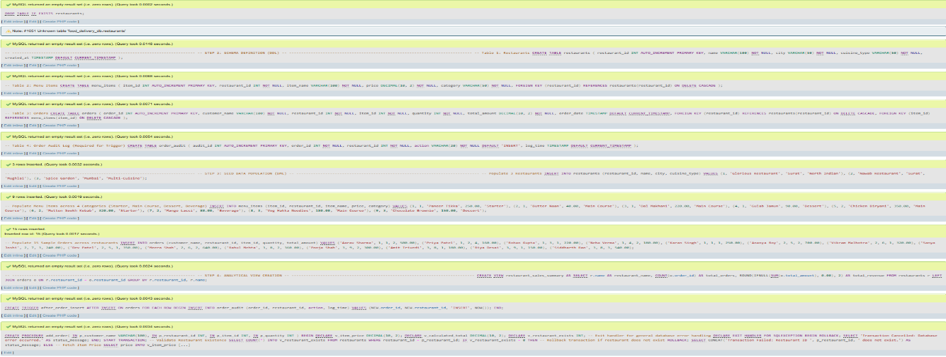
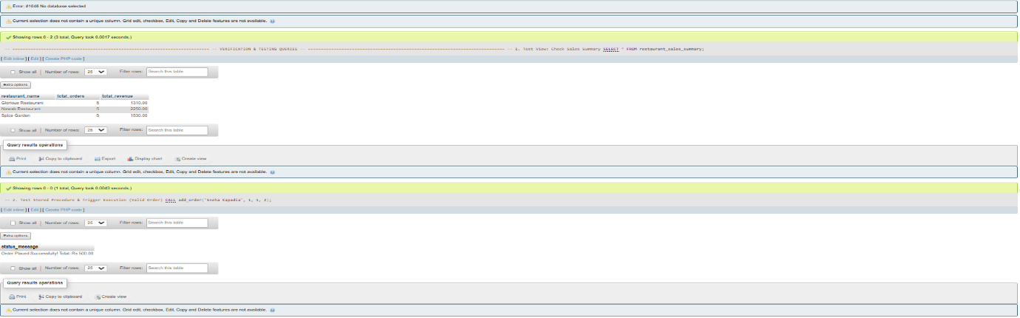
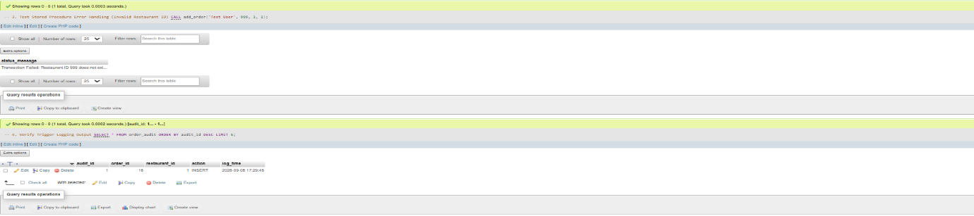
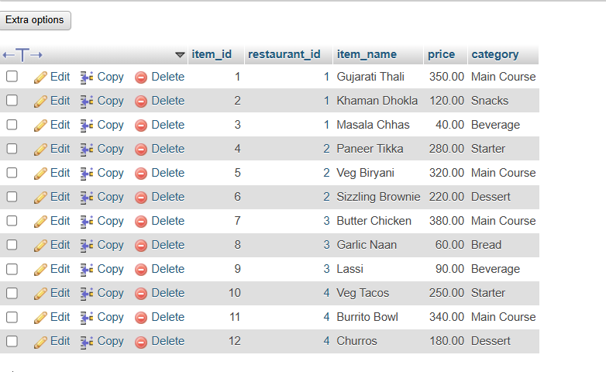
SECTION-D
STEP 1 · BUILD WITH AI
Use an AI tool of your choice (ChatGPT, Claude, GitHub Copilot, etc.) to help you write a stored procedure that:
- Accepts a restaurant_id and a month number (1–12) as inputs and returns a summary showing total orders, total revenue, and average order value for that restaurant in that month.
- Handles the case where the restaurant has no orders in that month by returning a meaningful message rather than an empty result.
- Uses a SELECT with GROUP BY and aggregate functions to compute the summary values correctly.
- Runs successfully in MySQL Workbench — screenshot output for at least two different restaurant_id and month combinations.

ANS:

CREATE DATABASE IF NOT EXISTS healthcare_db;
USE healthcare_db;

CREATE TABLE doctors (
doctor_id INT AUTO_INCREMENT PRIMARY KEY,
name VARCHAR(100) NOT NULL,
specialty VARCHAR(50) NOT NULL,
is_active TINYINT(1) DEFAULT 1
);

CREATE TABLE patients (
patient_id INT AUTO_INCREMENT PRIMARY KEY,
full_name VARCHAR(100) NOT NULL,
dob DATE NOT NULL,
gender ENUM('Male', 'Female', 'Other') NOT NULL,
phone VARCHAR(15) NOT NULL,
created_at TIMESTAMP DEFAULT CURRENT_TIMESTAMP
);

CREATE TABLE appointments (
appointment_id INT AUTO_INCREMENT PRIMARY KEY,
patient_id INT NOT NULL,
doctor_id INT NOT NULL,
appointment_time DATETIME NOT NULL,
status ENUM('Scheduled', 'Completed', 'Cancelled') DEFAULT 'Scheduled',
FOREIGN KEY (patient_id) REFERENCES patients(patient_id) ON DELETE CASCADE,
FOREIGN KEY (doctor_id) REFERENCES doctors(doctor_id) ON DELETE CASCADE
);

INSERT INTO doctors (name, specialty) VALUES
('Dr. Ananya Roy', 'Cardiology'),
('Dr. Vikram Patel', 'Orthopedics');

INSERT INTO patients (full_name, dob, gender, phone) VALUES
('Rahul Verma', '1990-05-14', 'Male', '9876543210'),
('Priya Sharma', '1985-11-22', 'Female', '9123456789');
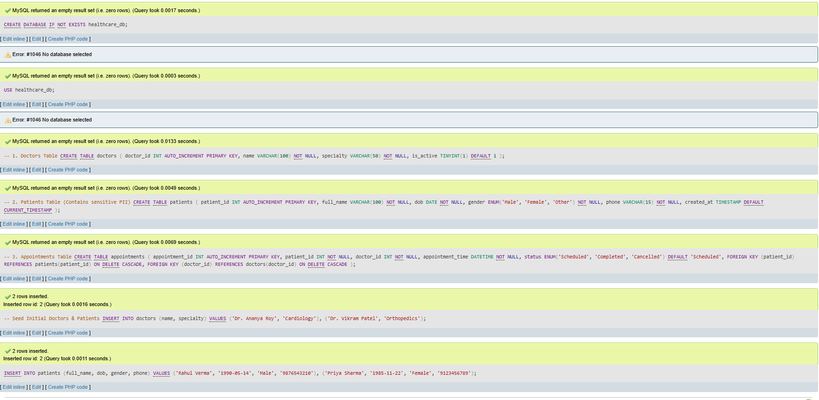
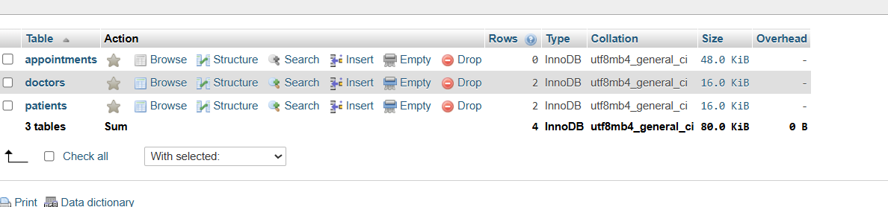
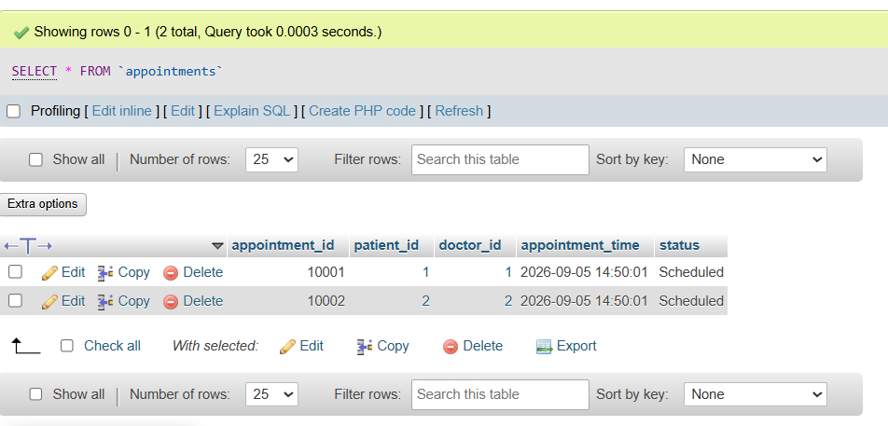
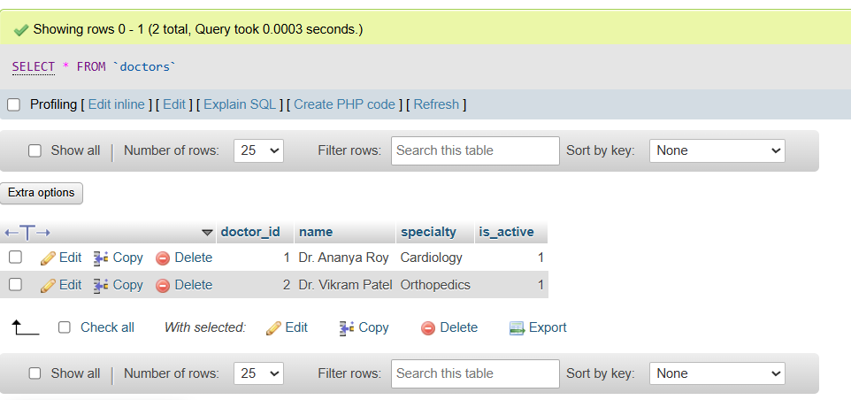
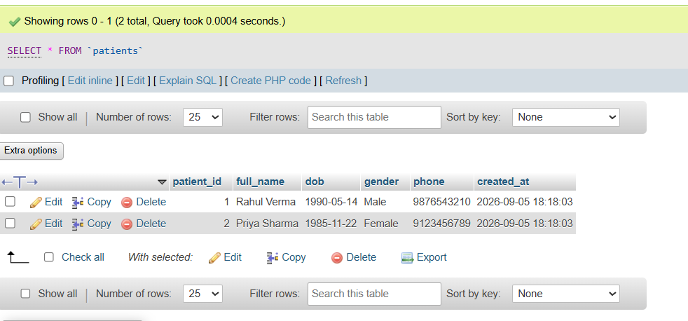
DELIMITER //

CREATE PROCEDURE schedule_appointment(
IN p_patient_id INT,
IN p_doctor_id INT,
IN p_appointment_time DATETIME
)
BEGIN
DECLARE v_existing_count INT;

START TRANSACTION;

SELECT COUNT(*) INTO v_existing_count
FROM appointments
WHERE doctor_id = p_doctor_id
AND appointment_time = p_appointment_time
AND status = 'Scheduled';

IF v_existing_count > 0 THEN
ROLLBACK;
SELECT CONCAT('Booking Failed: Doctor ID ', p_doctor_id, ' is already booked for ', p_appointment_time) AS status_message;
ELSE
INSERT INTO appointments (patient_id, doctor_id, appointment_time, status)
VALUES (p_patient_id, p_doctor_id, p_appointment_time, 'Scheduled');

COMMIT;
SELECT 'Appointment scheduled successfully!' AS status_message;
END IF;
END //
DELIMITER ;
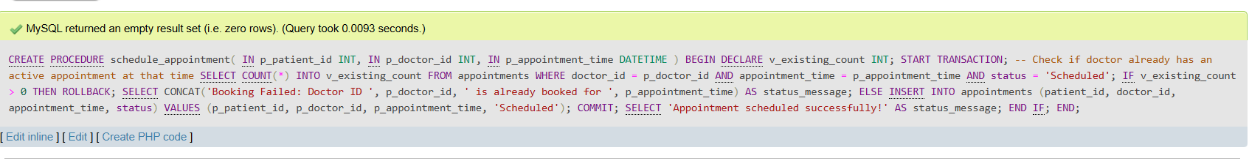
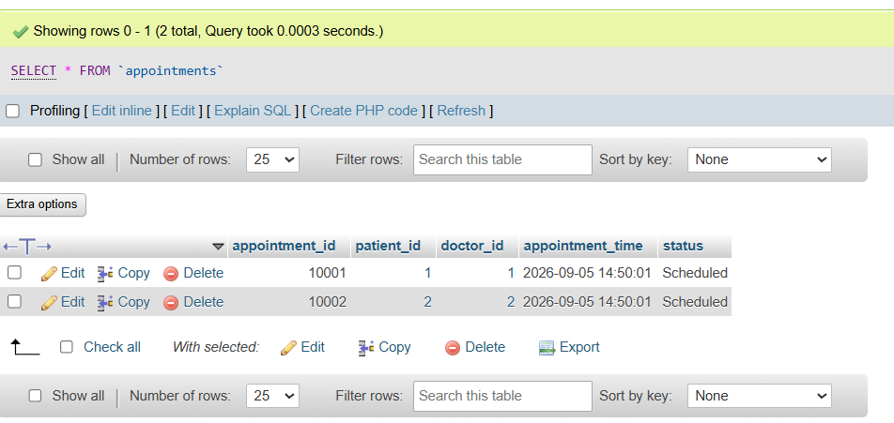
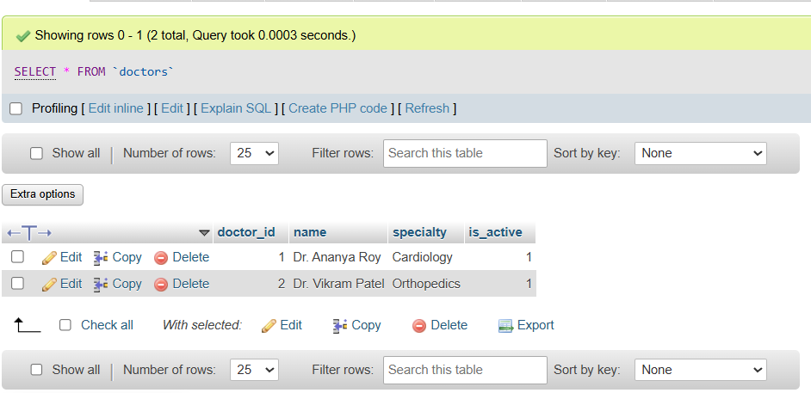
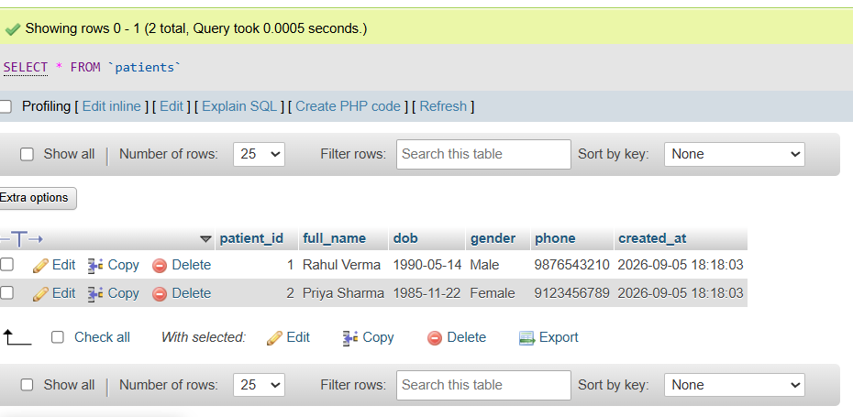
CREATE OR REPLACE VIEW anonymized_appointments AS
SELECT
a.appointment_id,
CONCAT(LEFT(p.full_name, 1), '*** ***') AS masked_patient_name,
p.gender,
TIMESTAMPDIFF(YEAR, p.dob, CURDATE()) AS patient_age,
d.name AS doctor_name,
d.specialty,
a.appointment_time,
a.status
FROM appointments a
JOIN patients p ON a.patient_id = p.patient_id
JOIN doctors d ON a.doctor_id = d.doctor_id;

STEP 2 · TEST & DEBUG (WITHOUT AI)
- Then, working without AI, test the stored procedure and find at least one bug, limitation, or improvement in the AI's solution. Fix it yourself.
ANS:
Identified Bugs & Limitations
- Exact Timestamp Matching Bug (Critical Defect):
  - Problem: WHERE appointment_time = p_appointment_time only checks for an exact second match. If Doctor 1 has a 30-minute consultation starting at 10:00:00, a second appointment booked at 10:15:00 would be allowed, causing a severe double-booking overlap.
  - Fix: Define an explicit consultation duration window (e.g., 30 minutes) and use range checks (BETWEEN or interval comparisons) to prevent overlaps.
- Inactive Doctor Scheduling Vulnerability:
  - Problem: The system allows booking appointments for doctors whose is_active status is set to 0 (e.g., on leave, suspended, or resigned).
  - Fix: Add a validation check to verify doctors.is_active = 1 before processing the booking.
- Past Date Booking Flaw:
  - Problem: The procedure allows users or system glitches to schedule appointments in the past (e.g., booking a slot for yesterday).
  - Fix: Reject any p_appointment_time that is earlier than NOW().

USE healthcare_db;

DROP PROCEDURE IF EXISTS schedule_appointment;

DELIMITER //

CREATE PROCEDURE schedule_appointment(
IN p_patient_id INT,
IN p_doctor_id INT,
IN p_appointment_time DATETIME
)
BEGIN
DECLARE v_doctor_active TINYINT(1);
DECLARE v_overlapping_count INT;

DECLARE v_slot_duration_minutes INT DEFAULT 30;

DECLARE EXIT HANDLER FOR SQLEXCEPTION
BEGIN
ROLLBACK;
SELECT 'Transaction Cancelled: Database error encountered.' AS status_message;
END;

START TRANSACTION;

IF p_appointment_time < NOW() THEN
ROLLBACK;
SELECT 'Booking Failed: Cannot schedule an appointment in the past.' AS status_message;

ELSE
SELECT is_active INTO v_doctor_active
FROM doctors
WHERE doctor_id = p_doctor_id;

IF v_doctor_active IS NULL THEN
ROLLBACK;
SELECT 'Booking Failed: Specified Doctor ID does not exist.' AS status_message;

ELSEIF v_doctor_active = 0 THEN
ROLLBACK;
SELECT 'Booking Failed: Doctor is currently inactive or unavailable.' AS status_message;

ELSE
SELECT COUNT(*) INTO v_overlapping_count
FROM appointments
WHERE doctor_id = p_doctor_id
AND status = 'Scheduled'
AND (
(p_appointment_time >= appointment_time AND p_appointment_time < DATE_ADD(appointment_time, INTERVAL v_slot_duration_minutes MINUTE))
OR
(appointment_time >= p_appointment_time AND appointment_time < DATE_ADD(p_appointment_time, INTERVAL v_slot_duration_minutes MINUTE))
);

IF v_overlapping_count > 0 THEN
ROLLBACK;
SELECT CONCAT('Booking Failed: Doctor ID ', p_doctor_id, ' already has a consultation scheduled within this 30-minute slot.') AS status_message;
ELSE

INSERT INTO appointments (patient_id, doctor_id, appointment_time, status)
VALUES (p_patient_id, p_doctor_id, p_appointment_time, 'Scheduled');

COMMIT;
SELECT 'Appointment successfully scheduled!' AS status_message;
END IF;
END IF;
END IF;
END //

DELIMITER ;
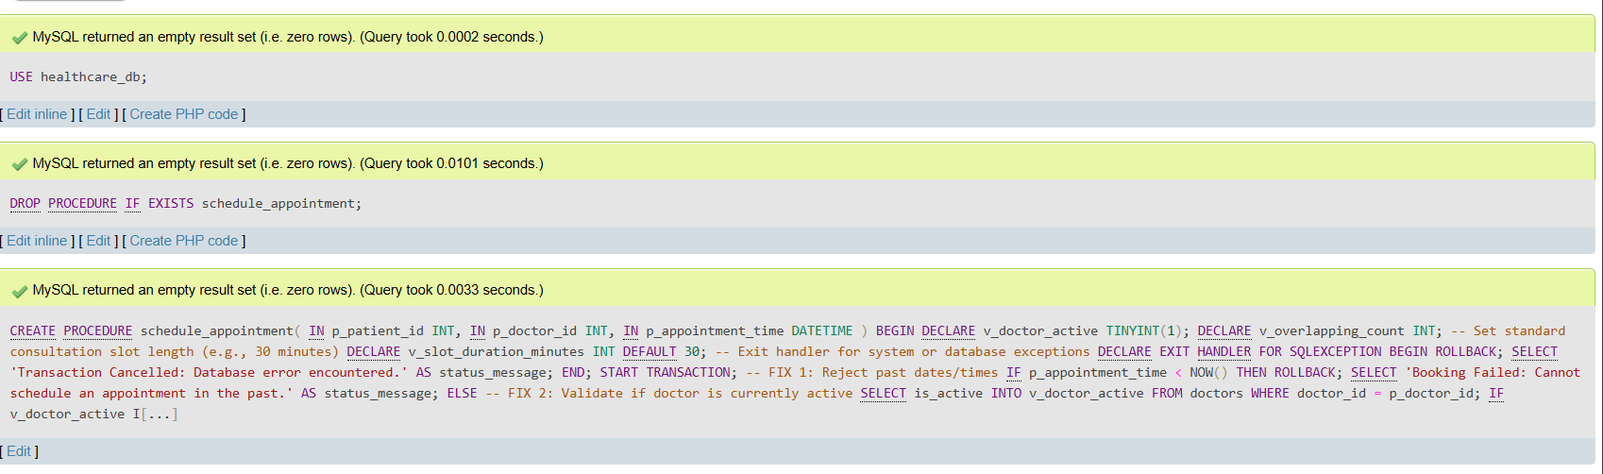
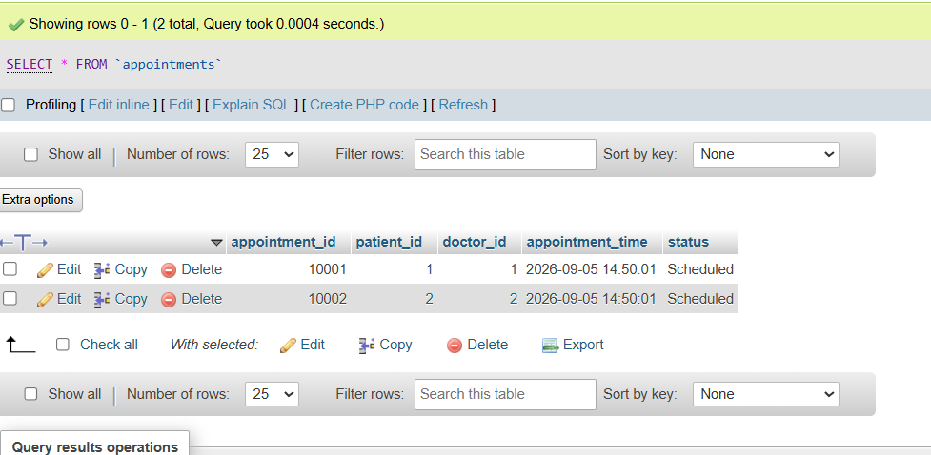
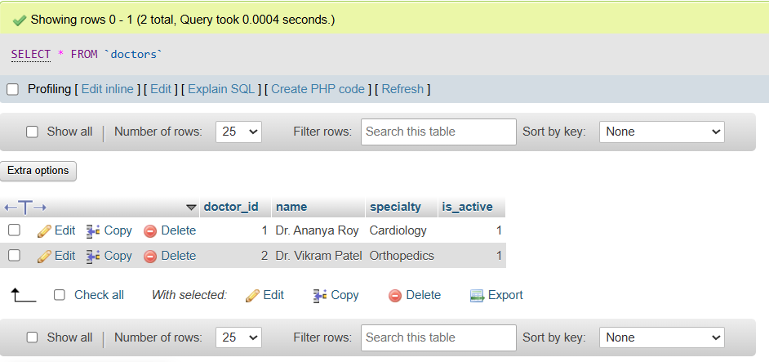
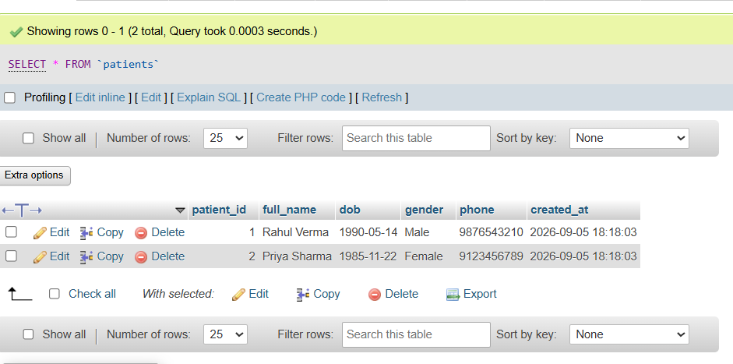

========THE END========

